1. Uploading file via Postman:

POST -> http://localhost:8080/upload

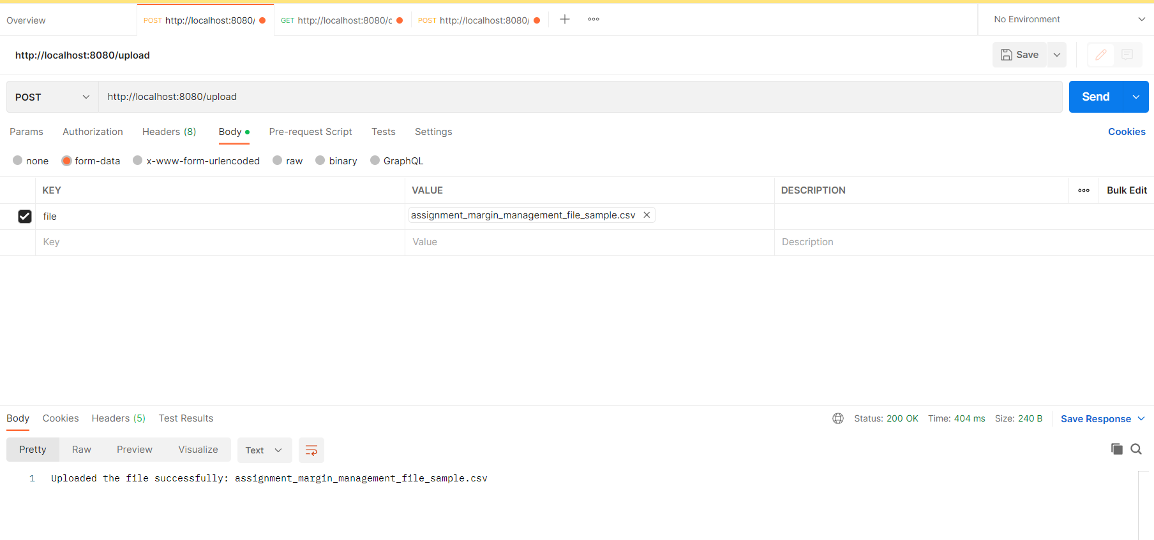

1. Download file

GET -> <http://localhost:8080/download>

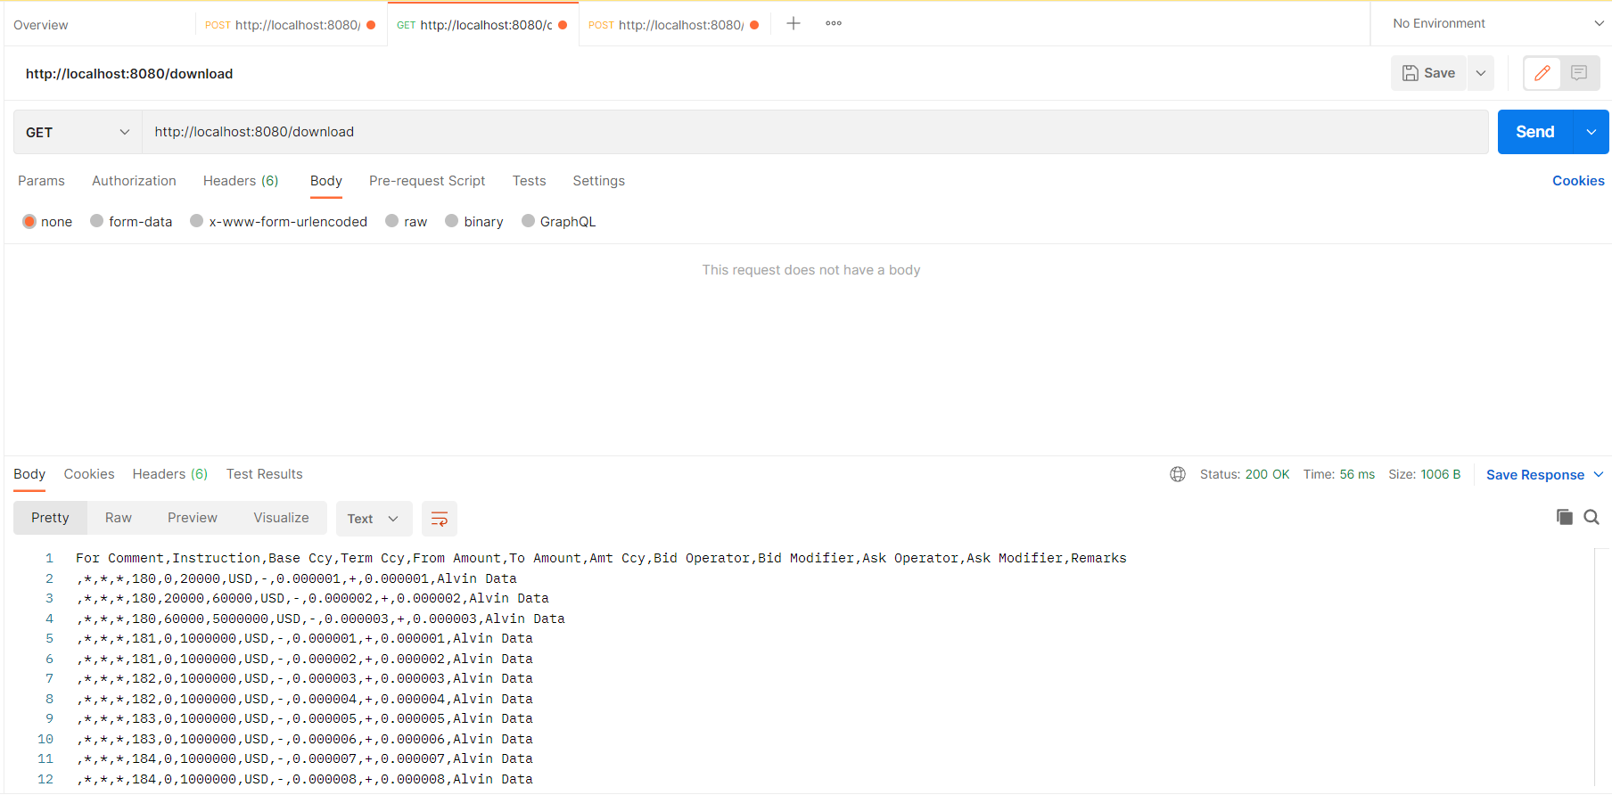

1. Find by Margin Endpoint

GET -> <http://localhost:8080/find>

